***BeeLazi’s UI PROTOTYPE***

***DESCRIPTIONS***

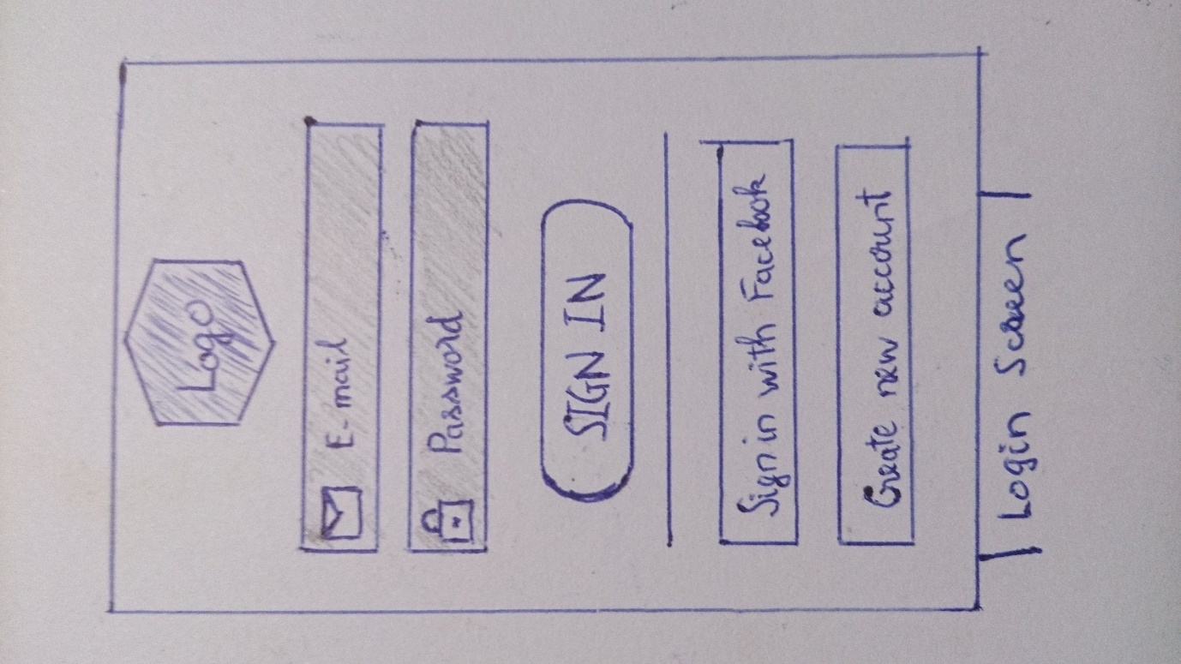

* 1. Login Screen: User can log in by their Facebook account by clicking on “Sign in with FB” button or to create a application’s base account by clicking on “Create new account” button.

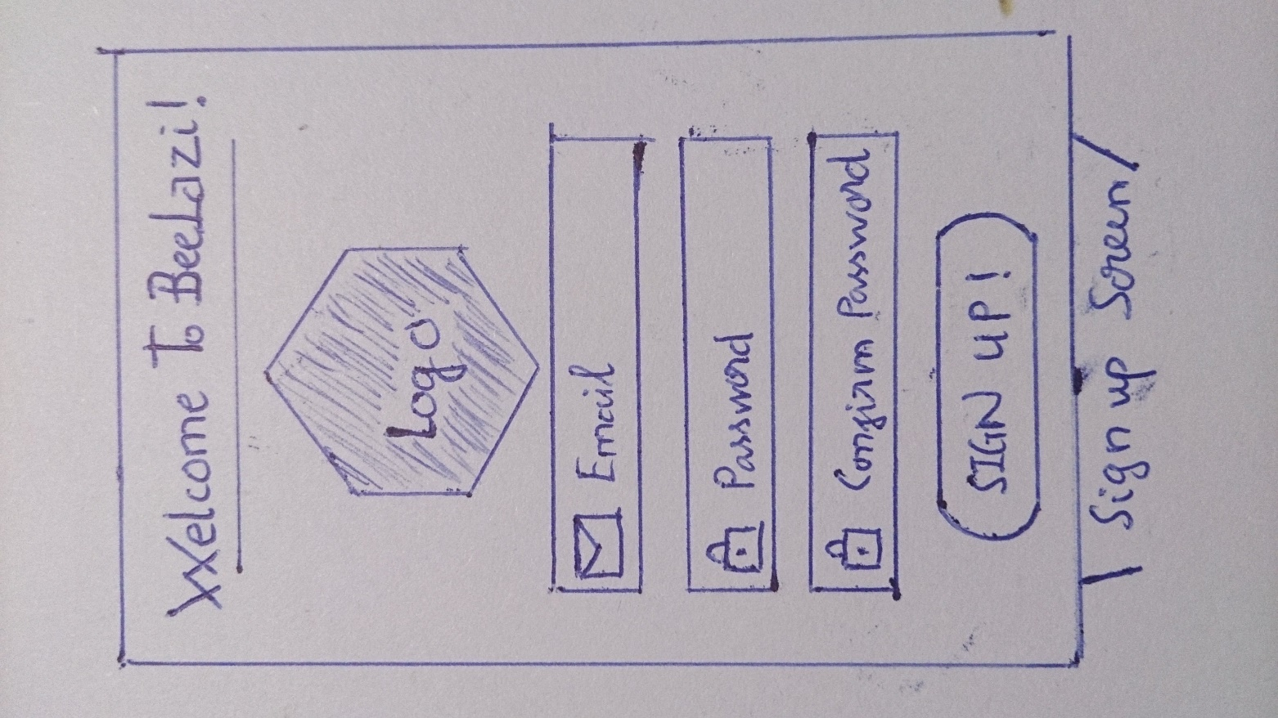

* 1. Sign up screen: by typing in their email account and password, user can sign in to the system with that account.

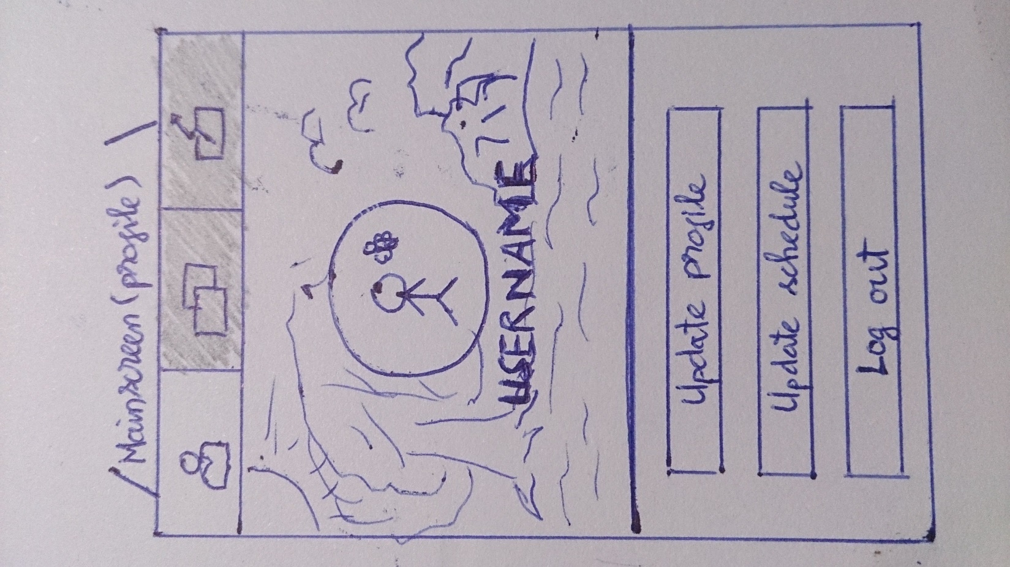

* 1. Mainscreen (profile): user can update their profile, schedule to the similar buttons.

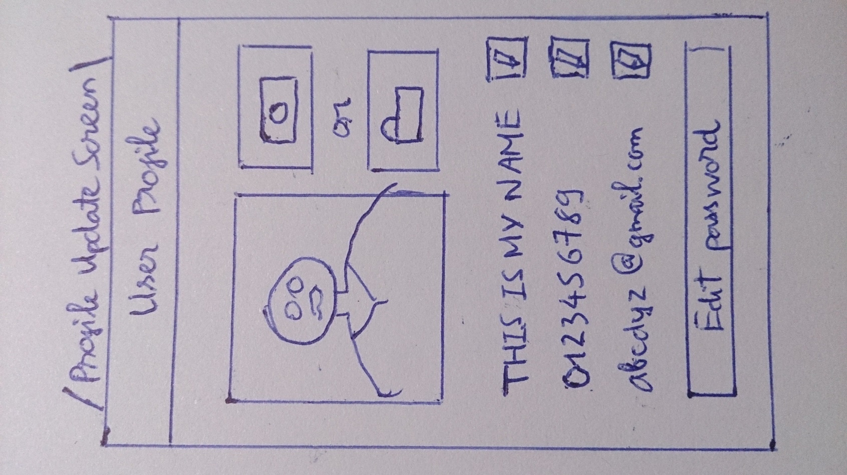

* + 1. Update Profile: They can change their profile’s picture by taking directly from camera or choose an existed image. User can change their phone number, their displayed name and email by clicking the button and change directly on that text box.

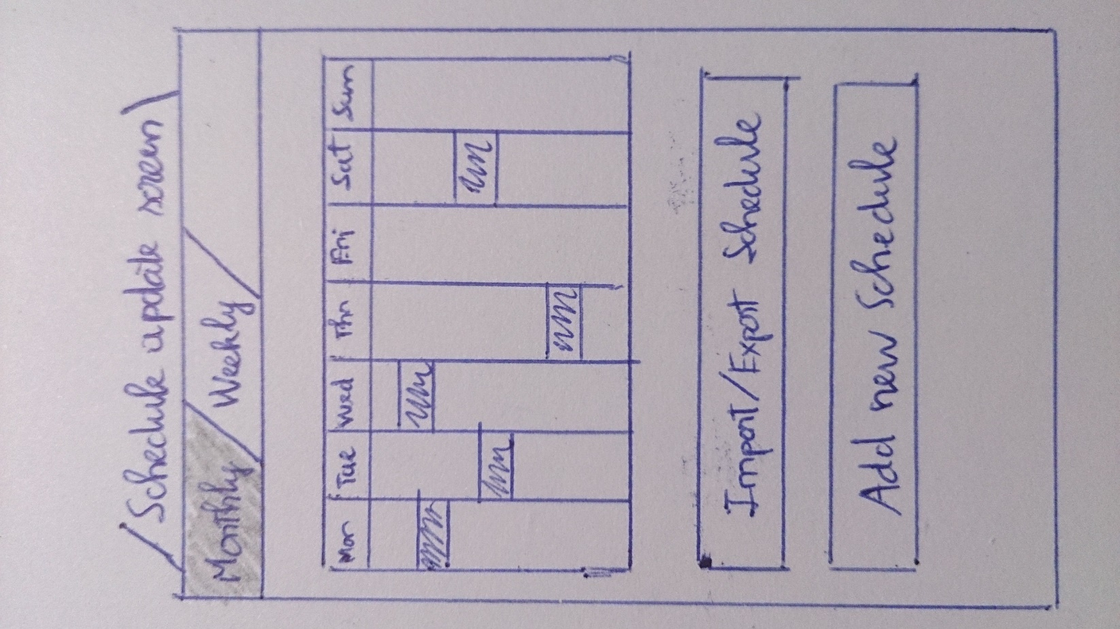

* + 1. Update Schedule: User can import or export their schedule from the device. Or add new schedule, displayed by week or month.

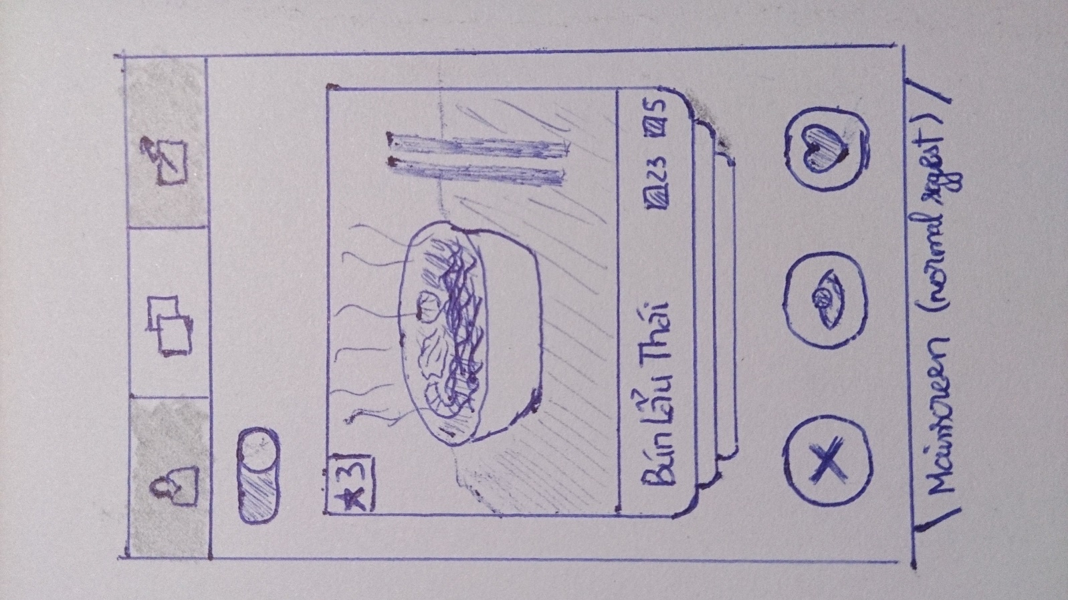

* 1. Mainscreen for normal suggest: The item displayed with picture, rating. User will vote for the item by swipe left (or touch X button), means they don’t like it. Or swipe that item to the right (or touch the Heart button) means they like it. User also have accessibility to view the detail of the item by touch the middle bottom button.

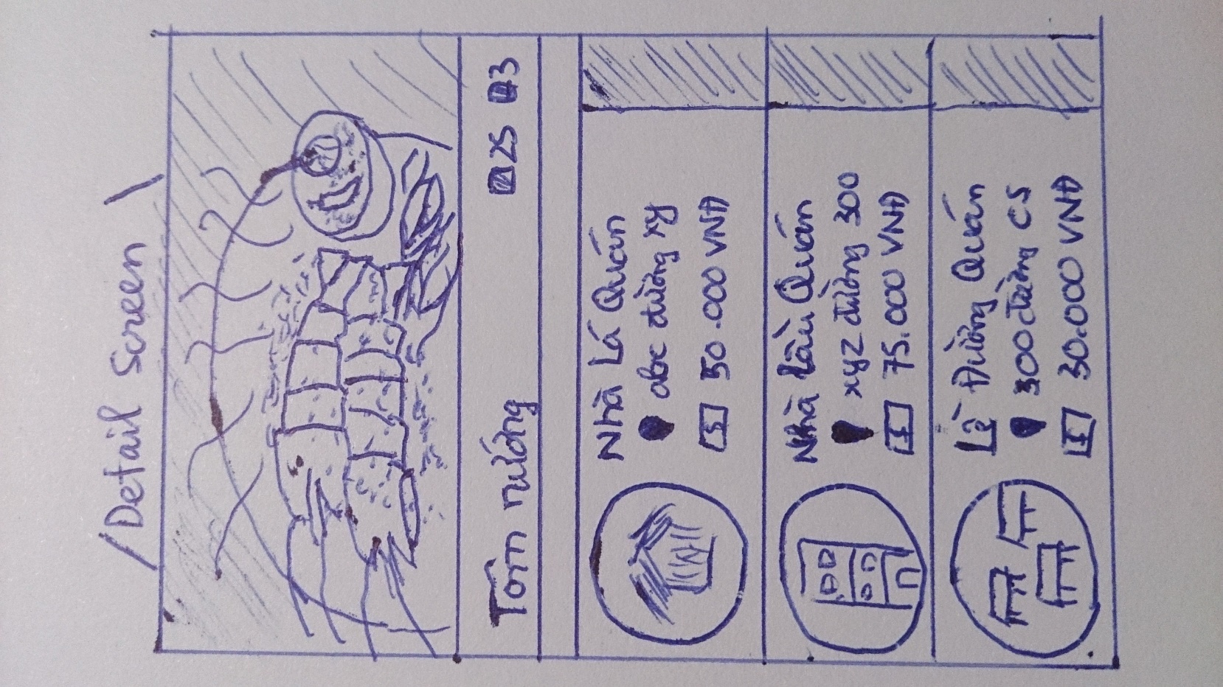

* 1. Detail screen of the item, user can view the place which offer that item along with the price and the address.

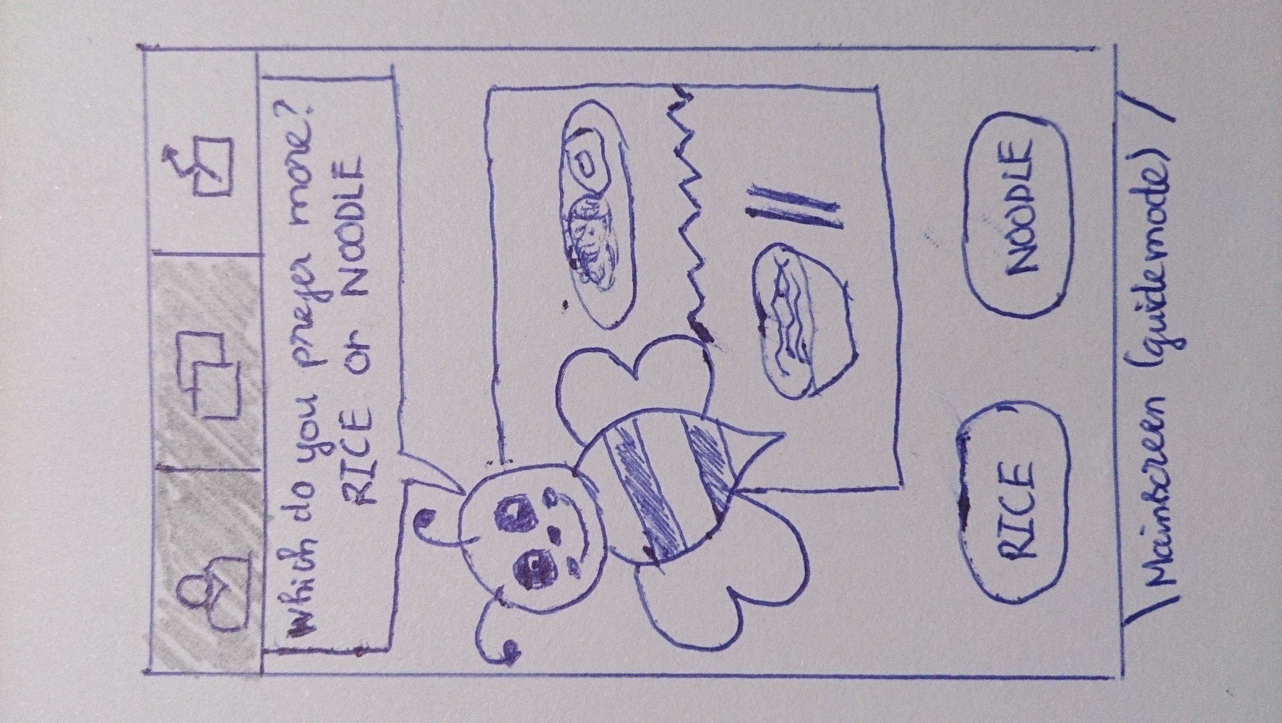

1.6 Mainscreen of guide mode: User are asked to choose between 2 or 3 items that we think they may like, which come from the previous interactions with the system.